# CS 340 README Template

## About the Project/Project Title

*This Project will demonstrate the CRUD functionalities in mongoDB with python as well as the dashboard components*

## Motivation

*The reason for creating this project is to learn how to create, read , update and delete documents within MongoDB. This is important because these functions are vital to noSQL. We can then populate the a dash data table to create an interactive user experience*

## Getting Started

*In order to get this working properly, you need to create an authorized user in mongoDB to access the database. Once you have that completed, you can write a script that has all of the functions of CRUD. Then you must create an additional script to import the code that was created prior in order to test that everything is working fine.*

## Installation

*mongoDB download link 🡪 https://www.mongodb.com/try/download/community*

*jupyter notebook 🡪 follow the instructions on this website* [*https://jupyter.org/install*](https://jupyter.org/install)

## Usage

### Code Example

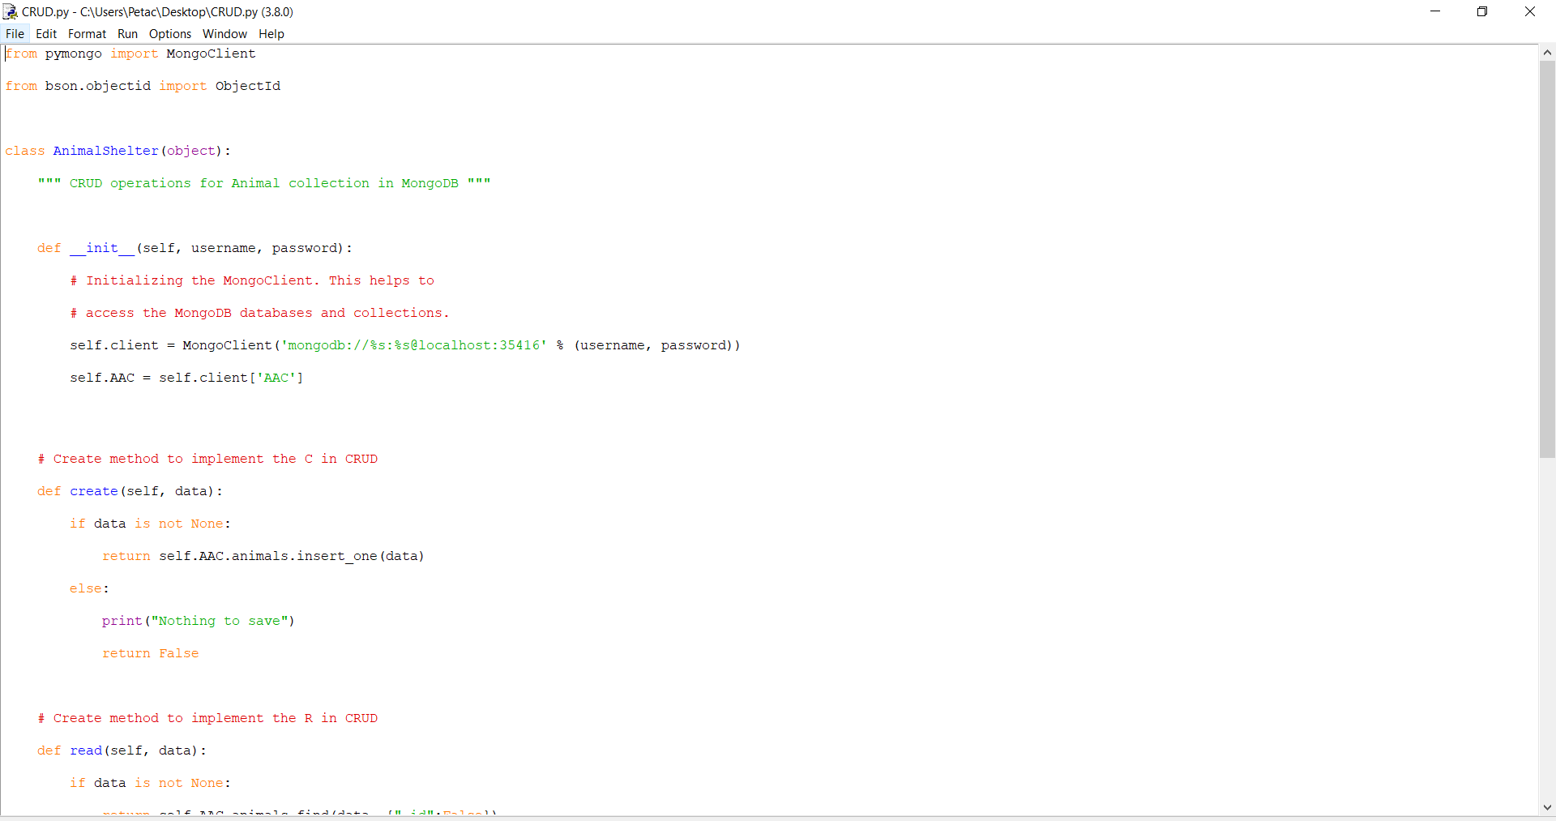

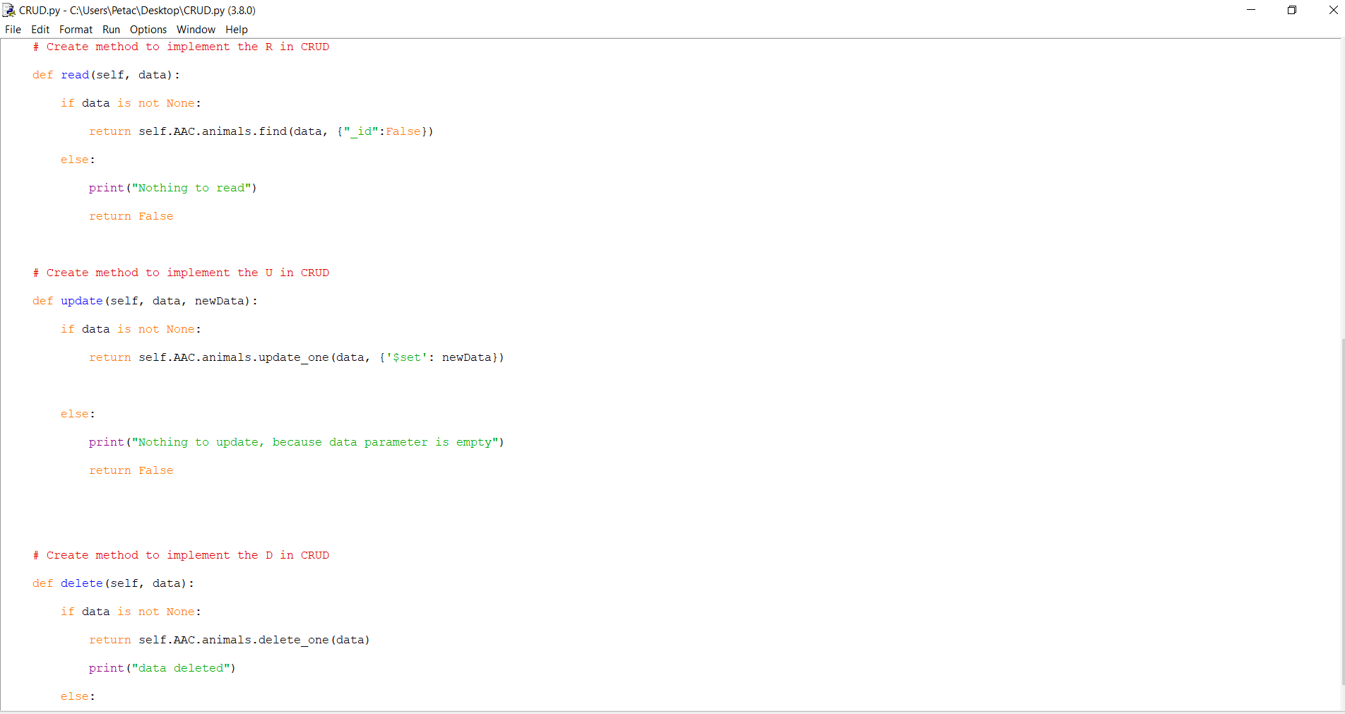

The code only has the create, read, update and delete functions made. The create function adds to the projects database and the animals collections. The read function finds the query in the collection. If input data in none, the program will raise an exception. The update function lets you update a current document by query. The delete function deletes a document by _id number.

### Tests

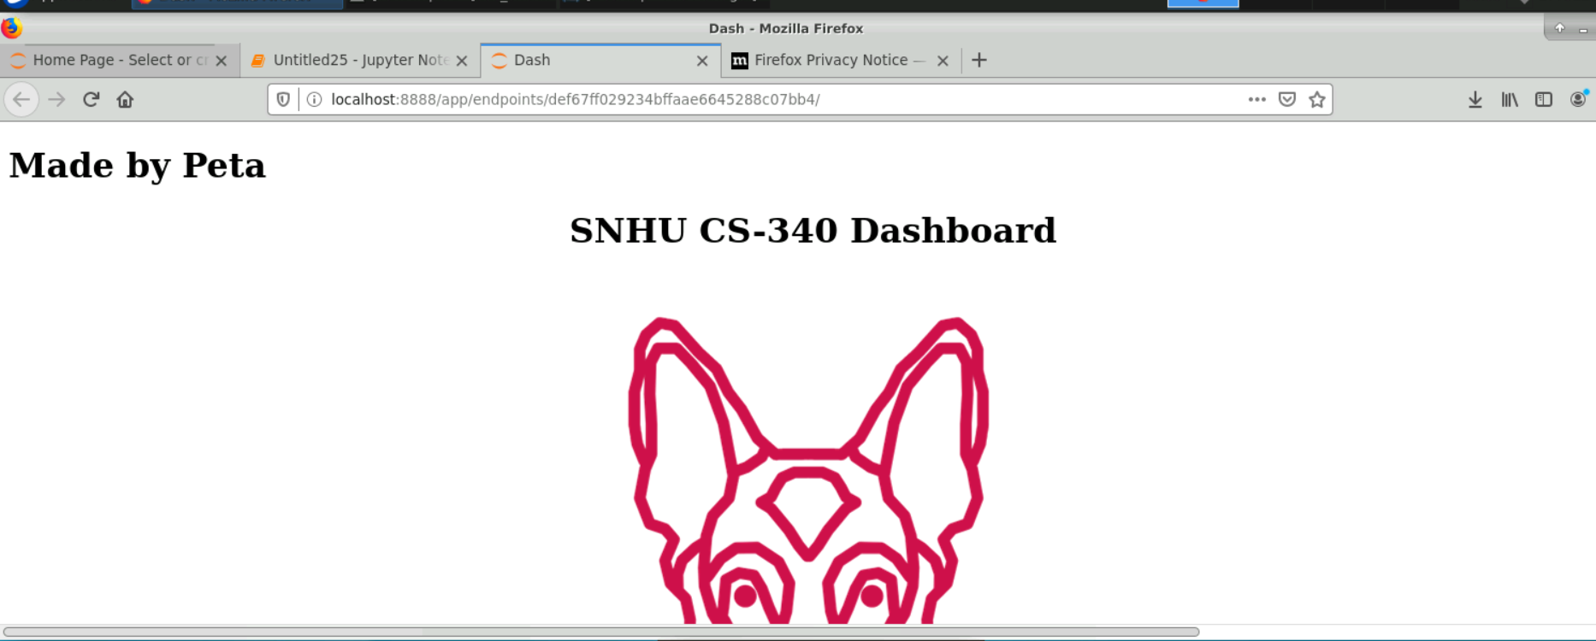

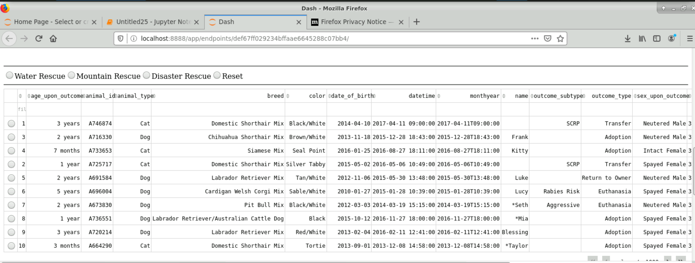

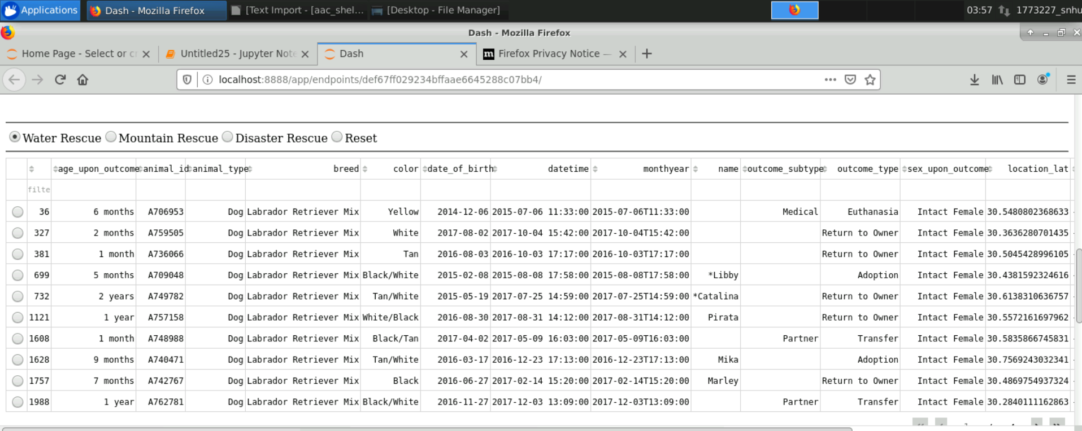

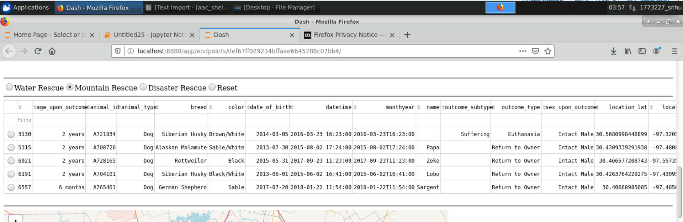

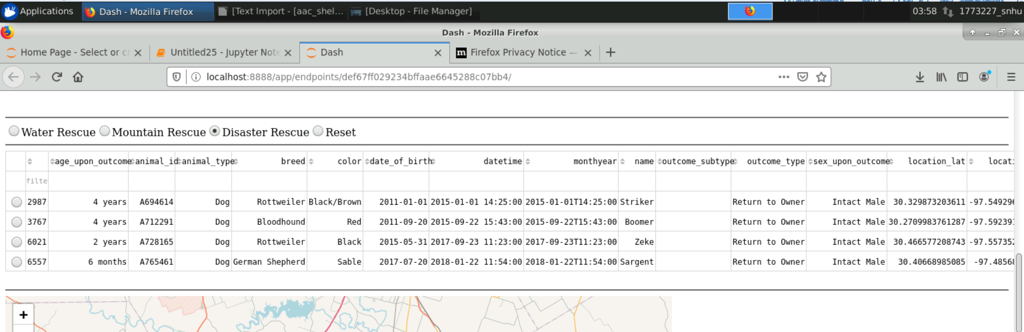

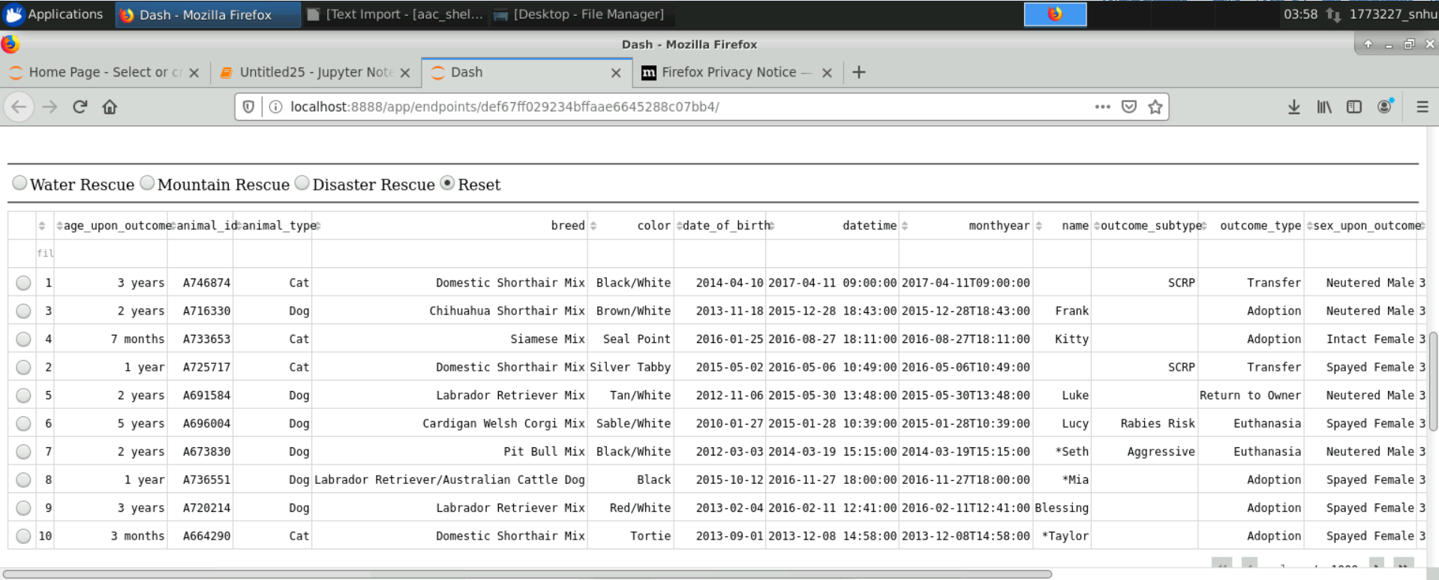

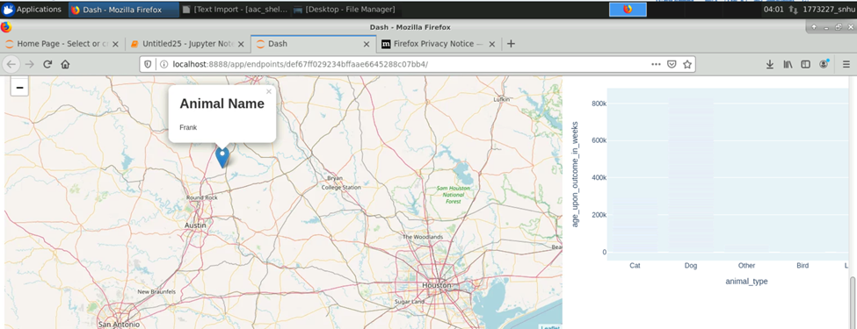

*This tests the interactive filter options.. It shows that the login authentication goes through and connects to the server. I was also able to create an instance of the object. This filters through for certain breeds and ages and sex. There is also a reset button to revert back. There is a geochart and a bar graph. MongoDb is great for managing data and can be to populate a python dashboard. Figuring out what to query was a big challenge for me. I had to read more to understand it better. Once I did, I was able to pull the data that I wanted. The dashboard layout was where most of the dashboard style elements came from. I was able to utilize it to style the dashboard to where it was interactive but also easy to understand.*

## Contact

Your name: Peta Clarke